Elton, Gruber, Brown, and Goetzmann
Modern Portfolio Theory and Investment Analysis, 9th Edition
Solutions to Text Problems: Chapter 19

Chapter 19: Problem 1

If earnings follow a mean-reverting process, then it is appropriate to use historical data to forecast future earnings. There are many appropriate techniques. Three specific ones are presented below.

A.
If earnings follow a mean-reverting process with no trend or cycle, the following exponential smoothing model could be used to forecast future earnings:

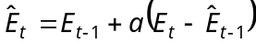

where

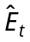 = the time-t forecast for earnings at time t + 1;

E_{t} = the actual earnings at time t;

a = a constant less than 1.0.

B.
If earnings follow a mean-reverting process with a trend but no cycle, either smoothed earnings plus the trend or smoothed earnings times the trend could be used, depending on whether the trend was additive or multiplicative. For example, with an additive trend the forecast would be:

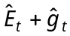
where

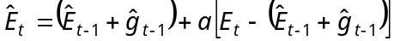;

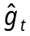 is the time-t estimate of the trend.
See footnote 7 in the text for further details on this technique.

C.
If earnings follow a mean-reverting process with a trend and a cycle, then the forecast is smoothed earnings adjusted for the trend and the cycle. For example, with an additive trend and a multiplicative cycle the forecast would be:

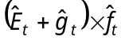
where is the time-t estimate of the cycle.
Chapter 19: Problem 2

If there was a strong relationship between a firm’s earnings and the overall industry’s and economy’s earnings, then, for example, a linear model could be estimated:

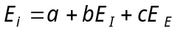

where

E_{i} = the firm i’s earnings;

E_{I} = the industry’s earnings;

E_{E} = the economy’s earnings.

Such an equation switches the forecasting task from forecasting E_{i} directly to forecasting it indirectly by first forecasting E_{I} and E_{E} and estimating the parameters a, b and c.

Chapter 19: Problem 3

YES. Mean reversion could be present in the industry’s and economy’s earnings, too.

Chapter 19: Problem 4

YES. The economy could also exhibit independence in earnings changes.

Chapter 19: Problem 5

If earnings expectations are important in determining share prices, then a valuable analyst is one who can forecast changes in investors’ expectations. If forecasts in general become more accurate over time, a valuable analyst is one who at any point in time can forecast more accurately than the average analyst can.

